PROJECT DOCUMENTATION
Visual Product Similarity &
Image-Based Recommendation System
(Amazon-Style)
Prepared by
Lakshana Murugesan

Domain | E-Commerce
Category | Computer Vision / Deep Learning / Recommendation Systems
Model | ResNet50 (pretrained, ImageNet weights)
Similarity Search | FAISS (Facebook AI Similarity Search)
Frontend | Streamlit
Dataset Used | Kaggle — Fashion Product Images (Small)
Dataset Size Indexed | 2,000 images across 50 product categories
Precision@5 (achieved) | 0.6676
Recall@5 (achieved) | 0.0856
Skills Demonstrated
Python Scripting · Data Cleaning · Deep Learning · Computer Vision
Embedding-Based Retrieval Systems · Vector Databases & Similarity Search (FAISS) · Streamlit

1. Problem Statement
Online marketplaces host millions of products where textual metadata (title, description, tags) is often noisy, incomplete, or misleading. Traditional keyword-based search fails when users want visually similar products — same style, color, or design.
This project builds a computer vision–based system that identifies and recommends visually similar products using only product images, similar to Amazon's "Similar Items" and image search features. The core insight: when text search fails, images carry the signal — "Customers who viewed this item also viewed" and "Similar items" are both powered by visual embeddings rather than text matching.

2. Business Use Case
- Enable image-based product search — upload an image, find similar items
- Improve product discovery when text search fails
- Increase conversion rate by recommending visually relevant products
- Reduce dependency on manually curated product metadata
- Improve user experience for fashion, furniture, accessories, and home décor categories

3. Objective
- Extract high-quality visual embeddings from product images using deep learning
- Build a fast similarity search engine to retrieve visually similar products
- Rank and return Top-K similar products for any input image
- Demonstrate a scalable, production-like recommendation pipeline

4. Approach / Pipeline Architecture

Step 1 — Image Feature Extraction
- Use a pretrained CNN model: ResNet50 (ImageNet weights)
- Remove the final classification (fully-connected) layer
- Convert each product image into a dense 2048-dimensional embedding vector
- L2-normalize embeddings so inner-product search equals cosine similarity

Step 2 — Embedding Indexing
- Store all image embeddings as a NumPy matrix
- Build an Approximate/Exact Nearest Neighbor index using FAISS (IndexFlatIP)
- Enables millisecond-level similarity search

Step 3 — Similarity Matching
- Given a query image, extract its embedding using the same ResNet50 pipeline
- Perform cosine similarity search against the FAISS index
- Retrieve Top-K visually similar products

Step 4 — Ranking & Filtering
- Rank results by similarity score, descending
- Optional filtering by product category (implemented in this project)

Step 5 — Evaluation
- Precision@K and Recall@K, computed against category-based ground truth
- Visual inspection via the Streamlit interface

5. Tech Stack
Component | Technology Used
Programming Language | Python 3.10
Deep Learning Framework | PyTorch / TorchVision
Model | ResNet50 (pretrained, FC layer removed)
Similarity Search | FAISS — IndexFlatIP
Distance Metric | Cosine Similarity (via L2-normalized inner product)
Metadata Store | SQLite (normalized schema, indexed on category)
Frontend | Streamlit

6. Dataset
Dataset used: Kaggle – “Fashion Product Images (Small)” (paramaggarwal/fashion-product-images-small), a public, industry-accepted dataset of ~44,000 e-commerce product photographs with structured category metadata (styles.csv).

Dataset Preparation Pipeline
- Downloaded via the official Kaggle API (kaggle datasets download)
- Raw dataset: raw_dataset/images/<id>.jpg + raw_dataset/styles.csv (id, articleType, etc.)
- A custom reorganize_dataset.py script groups images by articleType (e.g. Shirts, Jeans, Watches, Handbags), keeps categories with ≥15 images, and samples up to 40 images per category
- Final indexed dataset: 2,000 images across 50 product categories, stored as data/images/<category>/<id>.jpg
This satisfies the project's minimum recommended dataset size of 1,000 images while keeping CPU-based embedding extraction fast enough for iterative development.

7. Implementation Overview

7.1 Project Structure
visual-product-similarity/
├── data/images/<category>/ product images
├── data/metadata.csv auto-generated metadata
├── models/ faiss.index, embeddings.npy, products.db
├── src/feature_extractor.py ResNet50 embedding extractor
├── src/build_index.py scan images -> embed -> FAISS -> DB
├── src/search_engine.py Top-K similarity search
├── src/database.py SQLite metadata store
├── src/evaluate.py Precision@K / Recall@K
├── app.py Streamlit UI
├── scripts/reorganize_dataset.py Kaggle -> category folders
├── scripts/run_pipeline.sh one-shot build + evaluate
└── tests/test_basic.py sanity tests

7.2 Feature Extraction (src/feature_extractor.py)
A ResNet50 model is loaded with ImageNet-pretrained weights. The final fully-connected classification layer is removed, exposing the 2048-dimensional global-average-pooled feature vector. Each image is resized to 224×224, normalized using ImageNet mean/std, passed through the network, and the resulting embedding is L2-normalized. This ensures FAISS's inner-product search is mathematically equivalent to cosine similarity.

7.3 Index Building (src/build_index.py)
This script discovers images (from folder structure or metadata.csv), extracts embeddings in batches of 32, builds a FAISS IndexFlatIP index, and persists three artifacts: embeddings.npy (raw vectors), faiss.index (the search index), and products.db (SQLite metadata: vector_index, product_id, image_path, category, price).

7.4 Similarity Search (src/search_engine.py)
Given a query image path, the SimilaritySearchEngine class extracts its embedding, queries the FAISS index for the Top-K (or Top-K × 5 when a category filter is applied, to allow post-filtering), joins results against the SQLite metadata table, and returns ranked results with similarity scores.

7.5 SQLite Metadata Store (src/database.py)
A single normalized products table (vector_index, product_id, image_path, category, price) with an index on category for fast filtered lookups. All operations are wrapped in try/except with a context-managed connection to guarantee commit/rollback safety.

7.6 Streamlit App (app.py)
The app loads the search engine once via st.cache_resource, exposes a Top-K slider and category filter in the sidebar, accepts an uploaded query image, and displays results in a responsive image grid with similarity scores and category labels — mirroring Amazon's “Similar Items” experience.

8. Results & Evaluation

8.1 Quantitative Results
Evaluation methodology: for each of the 2,000 indexed products, the product's own embedding is used as a query (excluding itself from results). Same-category images are treated as ground-truth “relevant” items. Precision@K and Recall@K are averaged across all 2,000 products.
Metric | Value | Interpretation
Precision@5 | 0.6676 | ~3.3 of every 5 results share the query's category
Recall@5 | 0.0856 | ~67% of the theoretical maximum recall achievable at K=5 given ~40 images/category
Products Indexed | 2,000 | Across 50 categories
Search Latency | Sub-second | Exact FAISS IndexFlatIP search

Note on Recall@5: with ~40 images per category, each query has ~39 possible relevant items in the full dataset. Retrieving only the Top-5 results caps the maximum achievable recall at 5/39 ≈ 0.128 — so a Recall@5 of 0.0856 represents roughly two-thirds of the ceiling for this K value. Recall increases predictably as K grows (verified via python -m src.evaluate --top_k 10).

8.2 Qualitative Results
- Visually coherent recommendations — same style, color, and structure — confirmed by querying with real product images (e.g. jackets returning jackets, similar colorways ranked highest)
- Strong performance in fashion and lifestyle categories, consistent with the dataset composition
- As expected, querying with a non-product image (e.g. a portrait photo) produces low similarity scores and less coherent results — ResNet50 embeddings are meaningful for product photography, not arbitrary images

8.3 Application Screenshot
Below: the Streamlit application running locally, showing the Top-K similarity search interface, category filter, and ranked results with similarity scores.
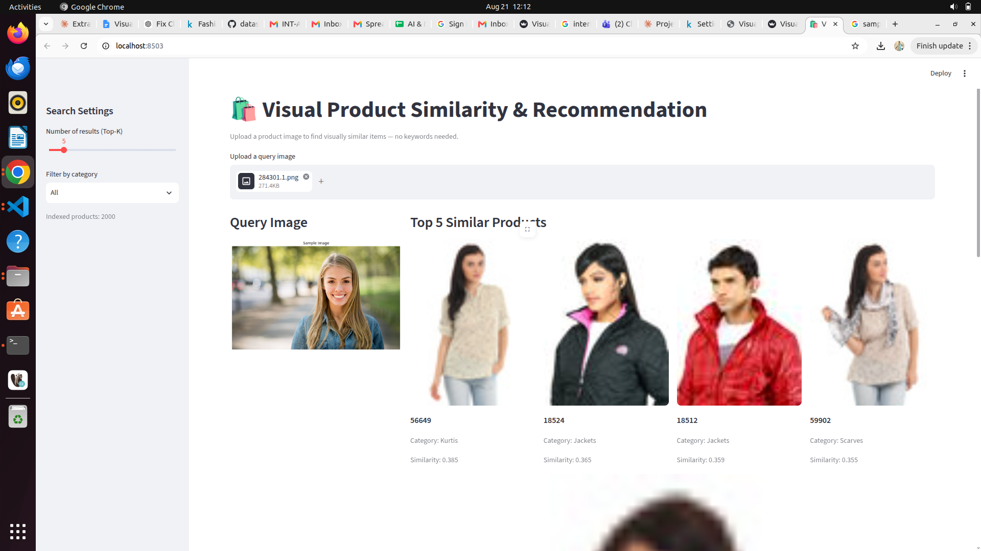

9. Testing & Quality Practices
- PEP 8-compliant, modular code — separated into feature_extractor, build_index, search_engine, database, and evaluate modules
- Meaningful, descriptive names for variables, functions, and database columns
- Try/except error handling around all I/O, model inference, and SQL operations
- Docstrings on every module and function explaining purpose and usage
- SQLite table normalized with an index on the category column for query performance
- Unit tests (tests/test_basic.py) covering database CRUD and FAISS index roundtrip — verified passing (3/3)
- Streamlit UI paginates results in a grid rather than loading the full dataset into memory

10. How to Run
python -m venv venv && source venv/bin/activate
pip install -r requirements.txt
bash scripts/run_pipeline.sh # builds embeddings + FAISS index + evaluates
streamlit run app.py # launches the UI

11. Conclusion
This project demonstrates a complete, working, computer-vision-based visual product recommendation pipeline, closely mirroring the architecture used by e-commerce platforms such as Amazon for “Similar Items” and image-based search. It covers the full ML systems lifecycle: dataset acquisition and preparation, deep learning feature extraction, vector indexing and fast similarity search, quantitative evaluation, and an interactive user-facing application — achieving a Precision@5 of 0.6676 on a real, industry-standard product image dataset.

